**Digital Circuit Project**

**User Requirement Specification**

**Document**

**Adrian Yankov**

**Quang Minh Pho**

**Denny Demara**

**Lyubomir Atanasov**

**Content**

Content………………………………………………………………………………………………………… 2

Introduction…………………………………………………………………………………………………. 3

User Interface Design…………………………………………………………………………………… 4

Use-case………………………………………………………………………………………………………. 5

Non-Functional Requirement………………………………………………………………………. 8

**Introduction**

This project was started by a group of ICT students from Fontys Hogeschool as their names mentioned above and we started this on 15-11-2012 in respect to our topic of our project.

This project aims to develop an application to help engineers devise better digital circuits by using logical values. It will test the output in advance in order to prevent future errors. By completing this project, we will solve this issue and satisfy the customer’s needs.

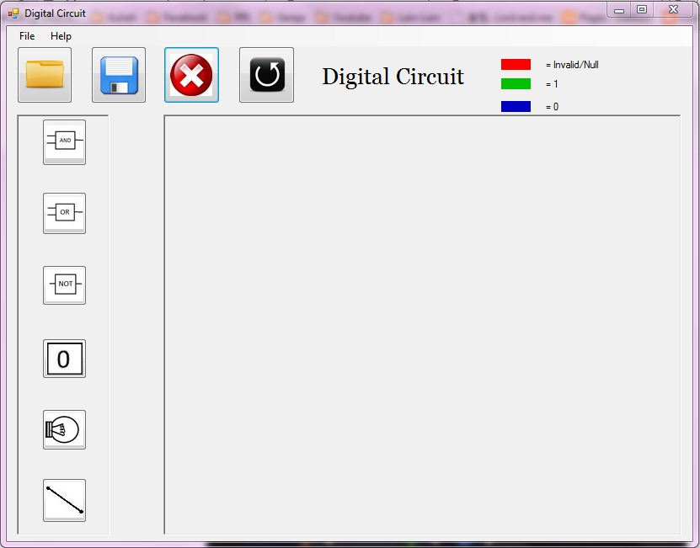**User Interface Design**

Help button to show the rules

Colors indication of logical value

The buttons for loading, saving, deleting, and undo

This is where the grids of the circuit will be

The gates and connection

**Use-Cases**

1. **Placing a Gate**

Actor: The user

Pre: The digital Circuit application is opened

MSS:

1. User selects gate.

2. User chooses where to place the gate on grid.

3. System places gate in the grid.

Ext 2a. Gate overlaps. System does not place gate, end use case.

Post: A placed gate.

1. **Connecting Two Gates**

Actor: The user

Pre: At least two gates placed

MSS

1. User chooses to add connection.

2. User selects the first gate.

3. User selects the second gate.

4. System connects the gates, and changes the color of the connections after the gate accordingly.

Ext 3. Connection not allowed, system show an error message to the user. End use case.

Post: The gates are connected

1. **Removing Connection between two Gates**

Actor: The user

Pre: An existing Connection between two gates

MSS:

1. User chooses to remove connection.

2. User selects connection.

3. System highlights the connection.

4. User chooses to delete it.

5. System deletes the connection, and the color of connections in the circuit changes accordingly.

Post: The connection is deleted

1. **Removing a Gate**

Actor: The user

Pre: At least one gate

MSS

1. User selects gate.

2. System highlights the gate.

3. User chooses to delete the gate.

4. System removes the gate and all connections to related gate.

5. System changes the colors of the connection and sinks accordingly.

Post: The gate is removed along with all its connections.

1. **Changing the Value of Source Gate (1 or 0 )**

Actor: The user

Pre: At least one source gate

MSS

1. User selects the source gate.
2. System highlights the gate.
3. System shows the switch option.
4. User chooses to modify the value.
5. System applies changes to the circuit, and changes the colors of the connection accordingly

Post: The value of the source gate is changed.

1. **Saving the circuit to a file**

Actor: The user

Pre: An existing circuit.

MSS

1. User chooses to save the circuit to a file.

2. System asks the user where to save it and the name of the file.

3. User confirms.

Ext: 2a) File already exists, System asks for a new name of the file or System overrides file.

Post: File is saved.

1. **Loading a circuit from a file**

Actor: The user

Pre: An existing file with the circuit

MSS

1. System asks the user where the file is.

2. System asks the user to choose the correct circuit file.

3. User browses for the file.

4. User confirms.

Post: The selected circuit file is opened.

1. **Undoing an action**

Actor: The user

Pre: At least one action has happened on the grid

MSS

1. User chooses to undo the last action.
2. System undoes the last action.

Post: The action is undone

**Non-Functional Requirements**

1. **System requirements**

* Windows 7
* Net framework 4
* Application having minimum technical errors
* Application running smoothly
* It’s not possible to crash the application in most case
* User Manual is not supported
* Undo function is available